**Getting Started Analyzing Data in Python**

**TOTAL POINTS 2**

1.

Question 1

What will be the result of the following line of code? **df.dtypes**

1 point



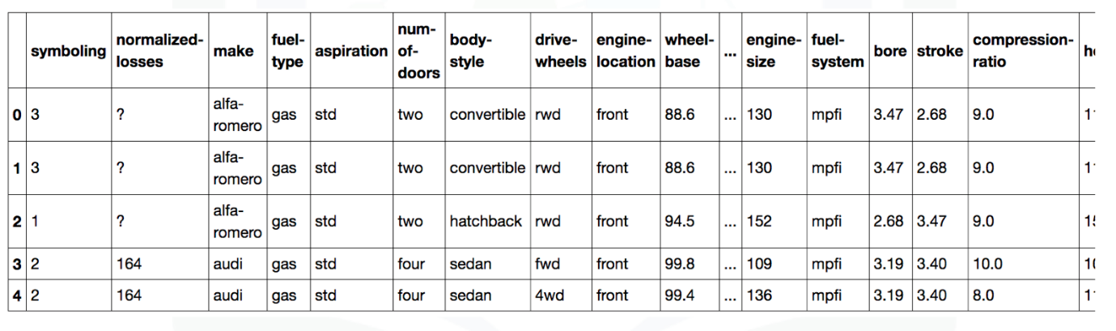

a)



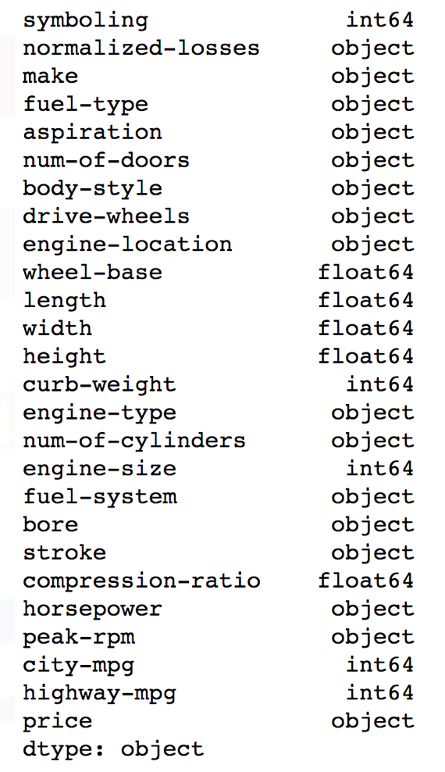

b)

2.

Question 2

To enable a summary of all the columns, what must the parameter **include** be set to for the method **describe?**

1 point



1

df.describe(include=“all”) 





1

df.describe(include=“None”)